**CSC 1101 – Problem Solving and Programming Laboratory**

**Lab 16 – Omar Faruk**

**25 points – Due November 10, end of lab**

**a)** Save this document with your name and the lab assignment number somewhere in the file name.

**b)** Type/paste your answers into the document.

**c)** Submit this document to the Canvas item where you downloaded this document.

***Problem Title: Student Senate***

Wayne State University is going to arrange a student senate election. Let, you are a programmer of the election commission of Wayne State University. You need to write a C++ console application which can automatically select the President of the Senate after getting the number of votes. You need to do the followings:

1. Declare a void function which can take three integer parameters. For example,

**void student_senate(int vote_A, int vote_B, int vote_C)**

**{**

**// write the function body here**

**}**

You should set the name of the function by yourself. It is better not to use the same function and variable name like the given one. These three integer variables represent the number of votes for person A, B, and C.

This function finds who got the highest number of vote and print the name of that candidate (The name of three persons are: Mr. A, Mr. B, and Mr. C).

1. If a single person does not get the highest vote, it prints for a re-election.
2. Take 3 values (the number of votes of A, B, and C) from the main function. Then pass these 3 values to the function and function prints the result.
3. Put header comments, body comments, and alignment.

Look at the sample input/output. Run your program at least 3 times and attach the output with different inputs.

**Sample Input/Output:**

*[your program code here]\**

//==========================================================

//

// Title: Wayne State Senate Vote Counter

// Course: CSC 1101

// Lab Number: Lab 16

// Author: Omar Faruk

// Date: 11/10/2020

// Description:

// Creating an apllication to determine student senate preside by taking

// the highest votes usig void function with if else.

//

//==========================================================

#include <cstdlib> // For several general-purpose functions

#include <fstream> // For file handling

#include <iomanip> // For formatted output

#include <iostream> // For cin, cout, and system

#include <string> // For string data type

using namespace std; // So "std::cout" may be abbreviated to "cout"

//Globals

const int COLMFT1 = 35;

const int COLMFT2 = 10;

// Void function to decide winner

void senators_school(int senator_X, int senator_Y, int senator_Z)

{

// If else statement to find highest votes

if (senator_X > senator_Z && senator_X > senator_Y)

cout << "\nSenator_X is elected as the president of the Student Senate";

else if (senator_Z > senator_X && senator_Z > senator_Y)

cout << "\nSenator_Z is elected as the president of the Student Senate";

else if (senator_Y > senator_X && senator_Y > senator_Z)

cout << "\nsenator_Y is elected as the president of the Student Senate";

else

{

cout << "\nThe top two/three senators got the same votes. Set a re-election" << endl;

}

}

int main()

{

// Declare variables5

int senator_X, senator_Y, senator_Z;

// Show application header

cout << "Welcome to Student Senate in Computer Science Deptartment!" << endl;

cout << "-----------------------------------------------------------" << endl << endl;

// Getting user input to set values

cout << setw(COLMFT1) << left << "Enter the number of votes for Mr. X: ";

cin >> setw(COLMFT2)>> right >> senator_X;

cout << setw(COLMFT1) << left << "Enter the number of votes for Mr. Y: ";

cin >> setw(COLMFT2) >> right >> senator_Y;

cout << setw(COLMFT1) << left << "Enter the number of votes for Mr. Z: ";

cin >> setw(COLMFT2) >> right >> senator_Z;

// void function to decide winner

senators_school(senator_X, senator_Y, senator_Z);

// Show application close

cout << endl <<"\nEnd of Student Senate in Computer Science Deptartment!" << endl;

}

*[your program output here]\*\**

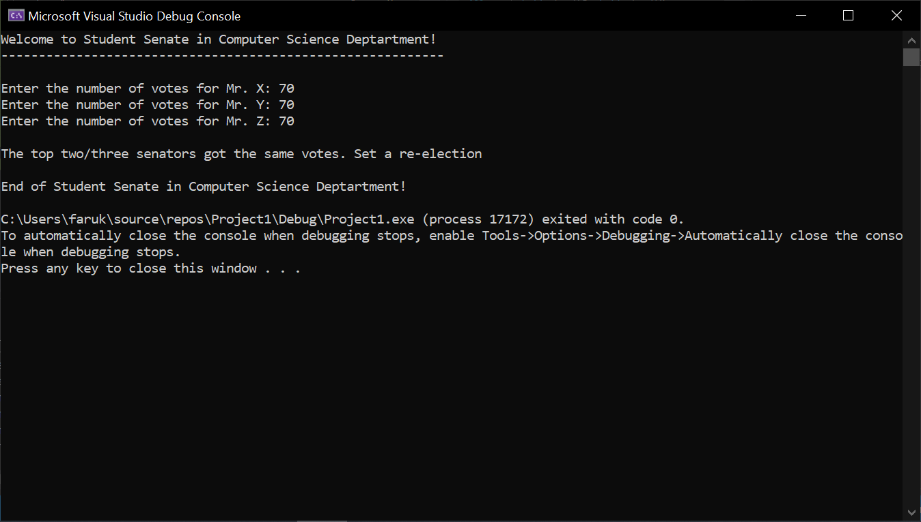

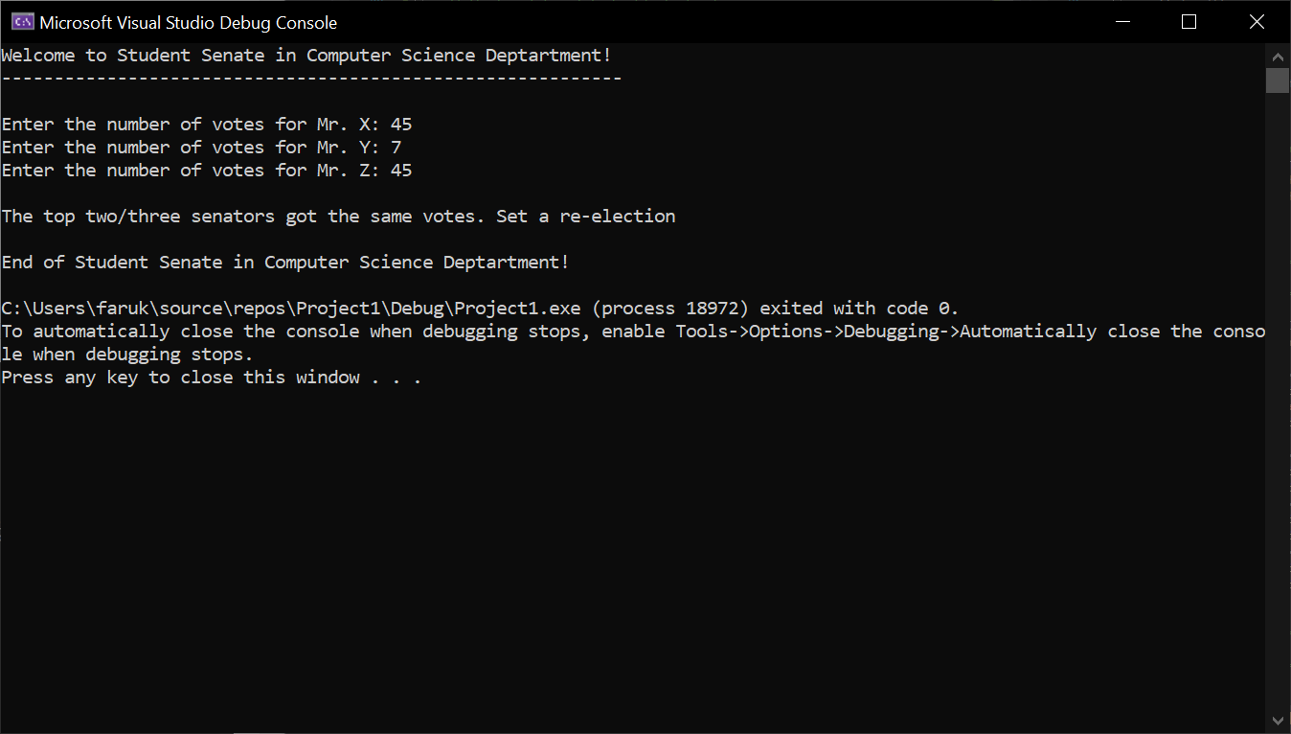

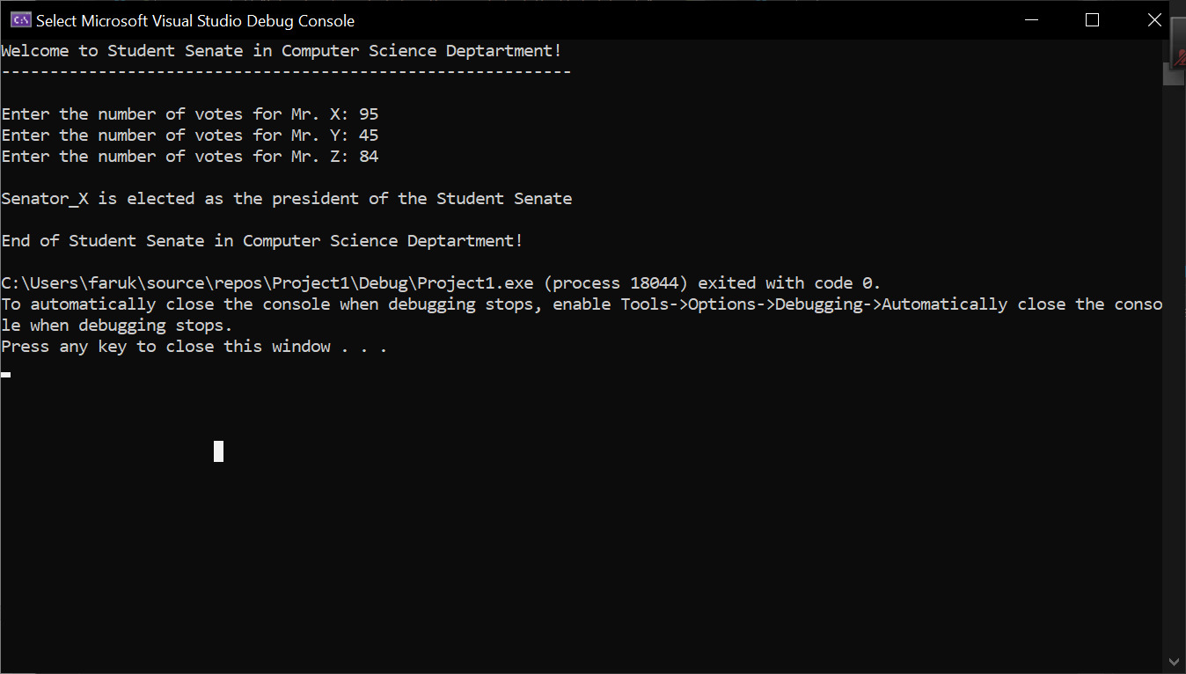

**\* Copying-and-pasting C++ code to a Word document**

**macOS**

1) From within the C++ program, press **command-A** and press **command-C**.

2) From within the Word document, press **command-V**.

**Windows**

1) From within the C++ program, press **CTRL-A** and press **CTRL-C**.

2) From within the Word document, press **CTRL-V**.

**\*\* Copying-and-pasting C++ console application output to a Word document**

**macOS**

1) From the C++ console, press **shift-command-4-space**.

2) From within the Word document, **command-V**.

**Windows**

1) From the C++ console, press **ALT-PrintScreen**.

2) From within the Word document, press **CTRL-V**.